In Room Follow Up Questionnaire
Patient Name:
Please check to confirm no changes to your Health Insurance/Attorney information
What is the reason for you visit today? _____________________________________________________
_____________________________________________________________________________________
Where is your pain today? Does it stay in one place or radiate? _________________________________
_____________________________________________________________________________________
Any changes since your last visit? _________________________________________________________
_____________________________________________________________________________________
Scale of 0-10, what is your pain level?______________________________________________________
Is the pain: (Circle all that apply)
Shooting Tingling Numbness Aching Burning Deep Dull Sharp Stabbing Throbbing
Specify any new medications or new medical conditions since your last visit?_________________________________________________________________________________
List all MRI’s, labs and any other testing done since your last visit (Include names of the facilities)?_____________________________________________________________________________
Are you currently in Chiropractic or Physical Therapy? _____________________________________________________________________________________
If applicable, what procedure did you have? How much relief did you receive? (0-100%)
_____________________________________________________________________________________
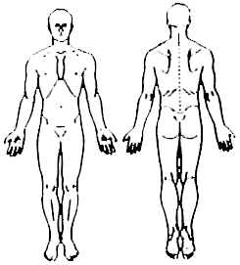
Please use the key below to indicate where your pain is located
Key:
X= PAIN *= PINS/NEEDLES
O= NUMBNESS /= ACHING

